Promotion Strategy
The Ultimate TV Chair will be marketed through multiple forms of media, including print, radio, and television, as well as Internet advertising. The promotions will predominantly target a modest to affluent, young adult audience, with a particular emphasis on the 21 to 40 year old age demographic.
Through our promotions, we will attempt to implement a product differentiation approach, positioning the Ultimate TV Chair as a value-based alternative to existing products on the market, with an emphasis on offering more amenities than the competition at a reasonable price. Additionally, the Ultimate TV Chair will also be marketed as a necessity to help improve or complement one’s experience while watching television. Because of this, we have decided to adopt the slogan “Take your television experience further” to help reflect this strategy. The conceptual print advertisement below presents an example of our promotion strategy:
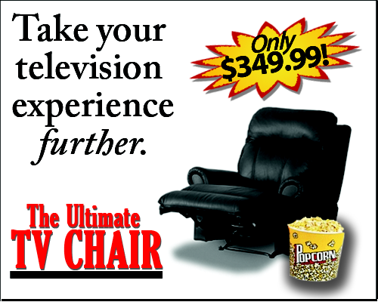

Place Strategy

An intensive distribution strategy will be implemented in order to maximize our product’s potential revenue stream and exposure. The Ultimate TV Chair will be distributed across the United States to a broad variety of retailers, including national chains, as well as e-commerce websites, and single-store operators. Through the use of cooperative advertising, we will seek to pay an additional amount to selected vendors in order to allow for the enhanced presentation of our products within the retail environment.
In order to best reflect our strategy of offering enhanced amenities at an affordable cost, the Ultimate TV Chair will be sold at a suggested retail price of $349.99.

